**Project Development Phase**

**Delivery of Sprint - 1**

|  |  |
| --- | --- |
| **Date** | 24 October 2022 |
| **Team ID** | PNT2022TMID45108 |
| **Project Name** | AI-based discourse for Banking Industry |

# Create IBM Service

In this activity, you will be creating the Necessary IBM service. The following are the service that you have to create.

•Watson Assistant

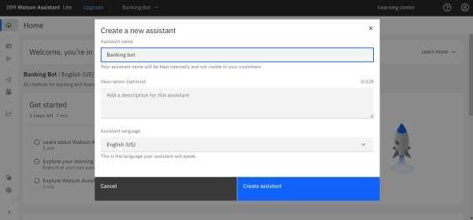

# Creating Skills & Assistant For Chatbot

Skills are nothing but actions and steps. Steps are the subset of actions where conversations are built and Assistant is used to integrate skills.

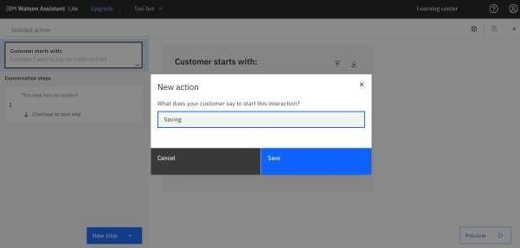

A default template chatbot is created. Need to add actions.



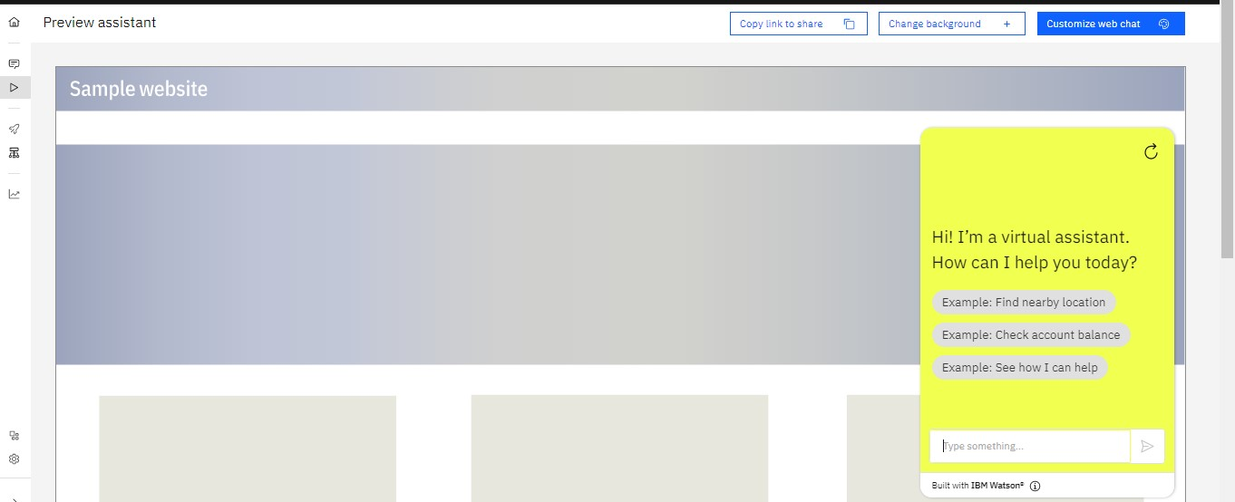

**Note:** No code for this project. So, I attached the screenshot and step to build it.